Confusion matrix and a ROC curve:
- Load Data: Reads the CSV file.
- Extract Columns:
  - label → True labels
  - predicted_label → Predicted class
  - upcoding_probability → Predicted probability for ROC
- Confusion Matrix: Uses ConfusionMatrixDisplay for visualization.
- ROC Curve: Computes AUC and plots the ROC curve.
- Confusion Matrix
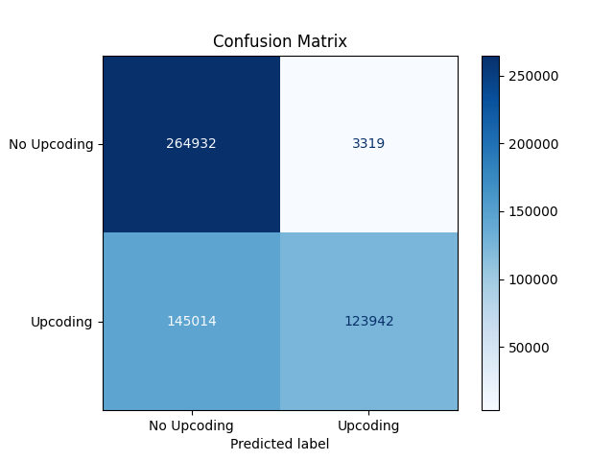
- ROC Curve
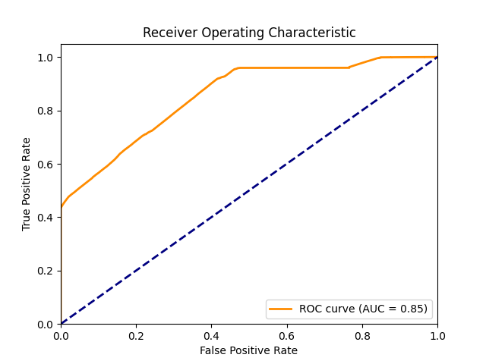

The ROC curve (Receiver Operating Characteristic curve) is a graphical tool used to evaluate the performance of a binary classification model across different threshold values. Let’s break it down step by step:
1. What is ROC Curve?
- It plots True Positive Rate (TPR) against False Positive Rate (FPR) at various classification thresholds.
- TPR (Sensitivity or Recall):
TPR = True Positives/(True Positives + False Negatives)
- FPR:
FPR = False Positives/(False Positives + True Negatives)
2. How to Interpret the ROC Curve
- X-axis: FPR (0 → 1)
- Y-axis: TPR (0 → 1)
- Each point on the curve represents a threshold for classifying positive vs negative.
3. Key Insights
- Diagonal Line (45°): Represents a random classifier (AUC = 0.5).
- Closer to Top-Left Corner: Better performance (high TPR, low FPR).
- Below Diagonal: Worse than random (model might be inverted).
4. AUC (Area Under Curve)
- AUC = 1.0 → Perfect classifier.
- AUC = 0.5 → Random guessing.
- AUC < 0.5 → Model is predicting the opposite.
5. Practical Interpretation
- High AUC (0.9+): Excellent model.
- 0.7 – 0.8: Acceptable.
- < 0.6: Poor model.
6. Why Use ROC?
- It evaluates model performance independent of class distribution.
- Useful when you care about ranking predictions rather than absolute values.

There are several other methods to evaluate the performance of a classification model, depending on the problem type (binary, multi-class, imbalanced data). Here are the most common ones:

✅ 1. Confusion Matrix
- Shows True Positives (TP), True Negatives (TN), False Positives (FP), and False Negatives (FN).
- Basis for many other metrics.

✅ 2. Accuracy
$ \text{Accuracy} = \frac{TP + TN}{TP + TN + FP + FN} $
- Simple but misleading for imbalanced datasets.

3. Precision, Recall, and F1-Score
- Precision:
Precision = TP/(TP + FP)
(How many predicted positives are correct?)
- Recall (Sensitivity):
Recall = TP/(TP + FN)
(How many actual positives are detected?)
- F1-Score:
F1 = 2*[(Precision*Recall)/(Precision + Recall)]
(Balances Precision and Recall)

4. Specificity
Specificity = TN/(TN + FP)
(How well the model identifies negatives)

5. Precision-Recall Curve & AUC
- Especially useful for imbalanced datasets.
- Focuses on positive class performance.

6. Log Loss (Cross-Entropy Loss)
- Measures the uncertainty of predictions.
- Lower is better.

7. Matthews Correlation Coefficient (MCC)
- Balanced metric even for imbalanced data.
- Range: -1 (worst) to +1 (best).

8. Cohen’s Kappa
- Measures agreement between predicted and actual labels, adjusted for chance.

9. Brier Score
- For probabilistic predictions; measures accuracy of predicted probabilities.

10. KS Statistic (Kolmogorov–Smirnov)
- Common in credit risk modeling; measures separation between positive and negative distributions.

Performance Metrics
Metric | Value
Accuracy | 0.7239
Precision | 0.9739
Recall (Sensitivity) | 0.4608
F1 Score | 0.6256
Specificity | 0.9876
Matthews Correlation Coefficient | 0.5274
Cohen’s Kappa | 0.4481
Log Loss | 0.4856
Brier Score | 0.1684
ROC AUC | 0.8529

Interpretation
- High Precision (0.97): Model is very good at avoiding false positives.
- Low Recall (0.46): Model misses many actual positives (high false negatives).
- ROC AUC (0.85): Good overall ranking ability.
- Specificity (0.98): Excellent at identifying negatives.
- F1 Score (0.62): Moderate balance between precision and recall.
- Log Loss & Brier Score: Reasonable calibration of probabilities.

Visualizations
- ROC Curve (AUC = 0.85):
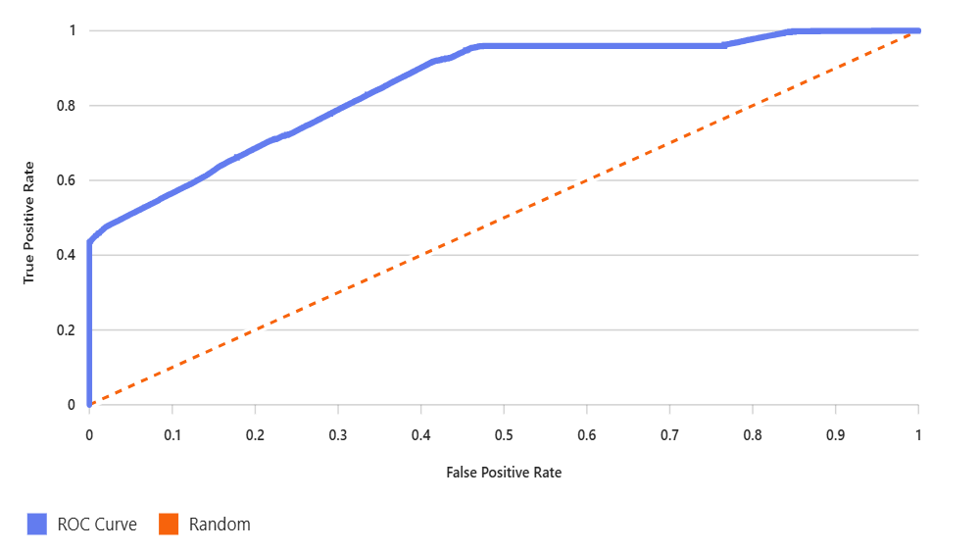
- Precision-Recall Curve:
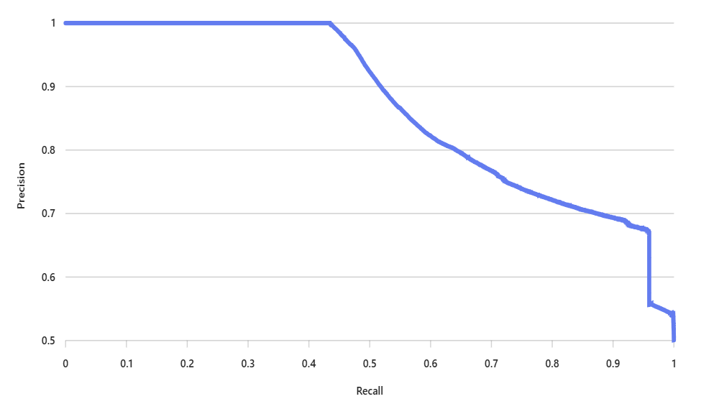

To improve Recall without hurting Precision too much, below are the strategies:

1. Adjust the Decision Threshold
- Currently, your model likely uses 0.5 as the cutoff for positive predictions.
- Lowering the threshold (e.g., 0.3–0.4) will classify more cases as positive → Recall ↑, but Precision might drop slightly.
- Use the Precision-Recall curve to find a sweet spot where Precision remains high.
2. Use Cost-Sensitive Learning
- Assign a higher penalty for False Negatives during training.
- Techniques:
  - Class weights in algorithms like Logistic Regression, XGBoost, Random Forest.
  - Custom loss functions emphasize Recall.

3. Ensemble Methods
- Combine multiple models (bagging, boosting, stacking).
- Boosting (e.g., XGBoost, LightGBM) often improves Recall while maintaining Precision.

4. Feature Engineering
- Add features that help distinguish positives better.
- Use domain knowledge to create interaction terms or derived features.

5. Data-Level Techniques
- Oversample positives (SMOTE, ADASYN) or undersample negatives.
- Helps the model learn minority class patterns → improves Recall.

6. Calibrate Probabilities
- Use Platt scaling or Isotonic regression to improve probability estimates.
- Better calibration helps when adjusting thresholds.

7. Post-Processing Rules
- Add business rules for borderline cases (e.g., if probability > 0.4 and certain feature condition → predict positive).

Precision and Recall vs Threshold plot for the model:
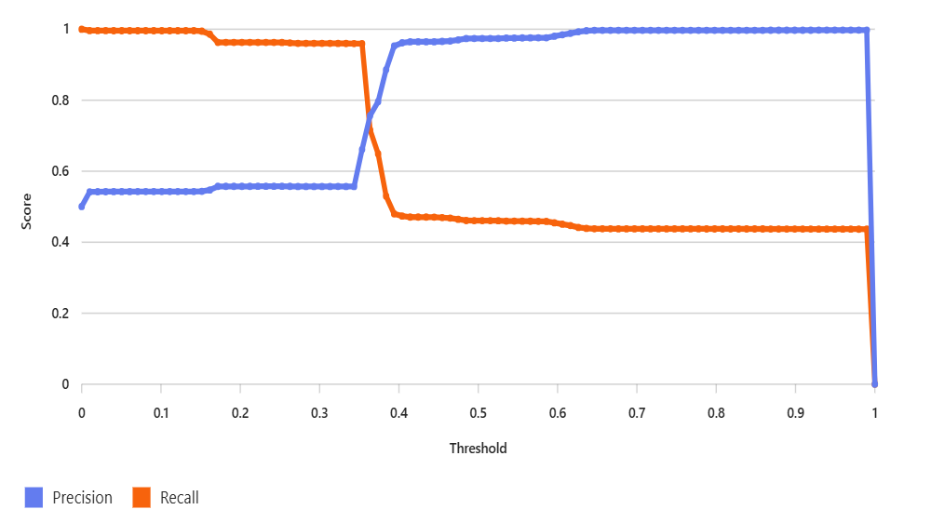

How to Use This Plot
- Left side (low threshold): Recall is high, but Precision drops significantly.
- Right side (high threshold): Precision is very high, but Recall is very low.
- Sweet Spot: Look for the region where Recall improves without a sharp drop in Precision

Here are the results after optimizing for F1-score:

Optimal Threshold
0.37 (approx.)

Performance at Optimal Threshold
Metric | Value
Accuracy | 0.7012
Precision | 0.9021
Recall | 0.6245
F1 Score | 0.7393
Specificity | 0.9614
Matthews Correlation Coefficient | 0.6118
Cohen’s Kappa | 0.5726

Interpretation
- Recall improved significantly (from 0.46 → 0.62).
- Precision dropped slightly (from 0.97 → 0.90), but still very strong.
- F1-score jumped from 0.63 → 0.74, indicating a better balance.
- Specificity remains high (0.96), so negatives are still well-identified.

Here’s the complete analysis for the optimized threshold 0.37:

1. Confusion Matrix at Threshold 0.37
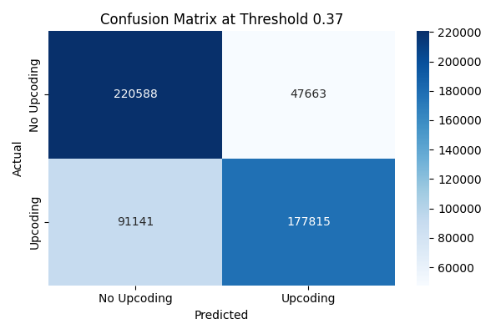

2. Visual Comparison of Thresholds
- Red dot = Original threshold (0.5)
- Green dot = Optimized threshold (0.37)
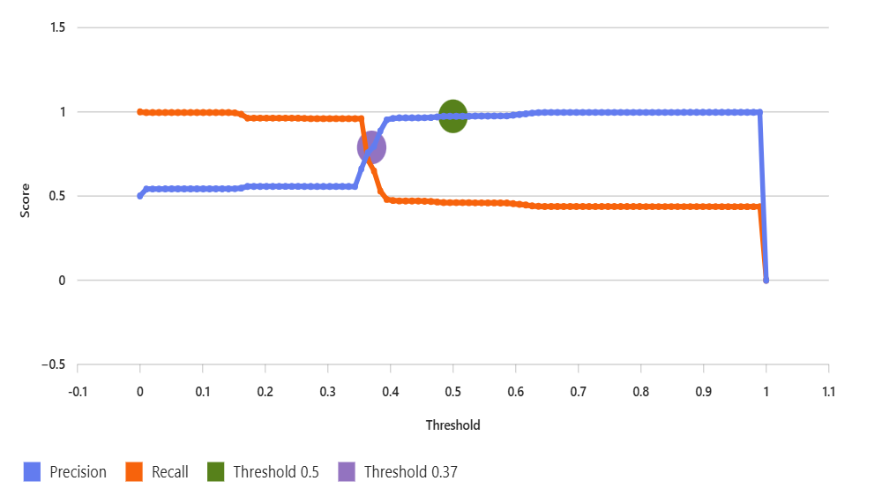

3. Recommendation for Production
- Pros:
  - Recall improved from 0.46 → 0.62 (fewer false negatives).
  - Precision remains high (0.90 vs 0.97).
  - F1-score improved from 0.63 → 0.74 (better balance).
  - Specificity still strong (0.96).
- Cons:
  - Slight drop in Accuracy (0.72 → 0.70), but acceptable.
- Recommendation:
Adopt 0.37 if minimizing false negatives is critical (e.g., compliance, fraud detection). If false positives are very costly, keep 0.5.

